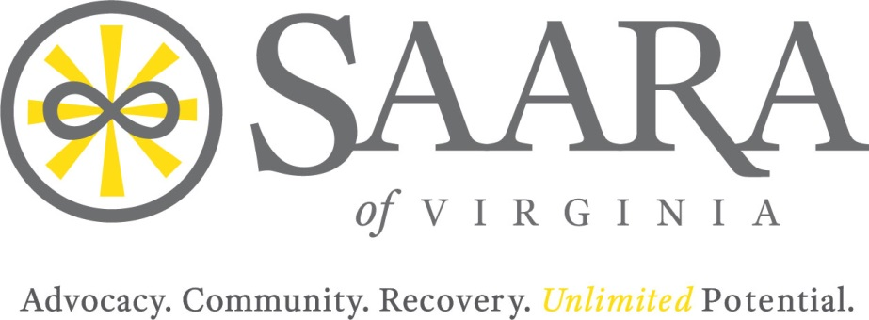

Monthly Meeting of the Board of Directors
2000 Mecklenburg Street, Richmond, VA
Saturday, May 12, 2018

Present: Alethea Lambert, Jim May, Melba Gibbs, Nick Yacoub, Barry Travis
Staff Present: Paige Bullen, Laura Madsen
Other: Johnnie Mullins
Absent: Michelle Brooks, Laura Minnick

Call to order
Called to order by Alethea Lambert at 10:17 am.

Introductions
Review of February 24, 2018 Meeting Minutes:
The minutes from the February 24, 2018 meeting were accepted unanimously with no changes.

***Action Item: Minutes will be posted on website.

January Financials Reporting
Board Members received the P&L by class from February and April as well as balance sheets through April. . Dr. May led a discussion over the financials and reviewed the balance sheet as of April 31, 2018. This included going over the loss from February’s balance sheet, and that loss recovering at the end of April. This is due to how payments come into the center due to quarterly billing process from grants. Dr. May gave two difference examples of the financial documents that are reviewed in the board meetings, detailed verses summary. Board members decided it was better to have the detailed financials at the meetings. When reviewing the Profit/Loss of April, the spike in meals and entertainment were explained by Paige as being from the 10th Anniversary, Recover Unhooked. When asked about the increase in equipment it was revealed that the computers were not labeled correctly in the financials. Dr. May will bring policies for review in order to differentiate between equipment and supplies.

**Action item: Find out what the Accumulated Depreciation amount of $275.00 includes from the April 30th, 2018 Balance Sheet. Also need to get details on what “General Fund” under equity includes.

Dr. May informed the board of the current balance of nearly $80,000 in the checking account at the end of April reflecting that we are currently in good shape financially. To close the update of the financials, Dr. May reviewed and discusses all credit card charges with the board for the months of February, March and April.

Bay Counties
Barry Travis updated the present members on Bay Counties finding space for SAARA to work out of. Rent will not be charged. Grant has been created and submitted with the assistance of Paige in order to get the office up and running with supplies. Barry Travis also informed the present members that CSB had furniture that they need to sell and possibly donate the proceeds to SAARA.

Central Virginia
SAARA of Central Virginia is continuing to work with RBHA and the Art of Recovery event with Paige. The fundraiser will include art classes at several locations including the SAARA Center.

Nova
Nick updated the present members on his efforts to continue to increase SAARA’s reach in NOVA. Nick continues to advocate for SAARA at many speaking engagement that include Fairfax SCB, Alexandria Police Department, Fairfax County Police and the Fairfax County Hospitals. . He has also found a potential space for Recovery Unhooked 3 at George Mason University which would cost $1500.00 to rent. Nick is currently resigning from an outside position and will be able to spend more time working in NOVA to advocate for SAARA.

Southwest Virginia
Paige is continuing to work with our affiliates in Southwest Virginia. She recently worked with Trish White and contacts at Carilion and provided a letter of support from SAARA for a grant application that Carilion submitted from SAMHSA. This would fund a drop-in peer center in Roanoke and Trish would likely mange the center.

Peninsula
SAARA of the Peninsula recent voted for a new Vice Presidents, Johnnie Mullens, as the other has stepped down. Alethea updated the board on the recent strategic retreat that was held at the beginning of the month and presented by Paige Bullen. After the retreat there were discussions about creating another workshop day and possibly view a movie that could be shared with the community. A $15,000 grant from DBHDS was received and has been used for bus tickets, new computers, promotional items and extend their storage space out through 2020. The Peninsula has been promoting their “Where You at Group,” which allows a time for Peers and Clients to have time to meet up before scheduled meetings. This has turned into an opportunity for Peers to meet and offer support for each other. Alethea also informed the board that there is a potential paid opportunity with Marva Maid, as they contacted SAARA to potentially come in on each of their shifts to speak about recovery. Board spoke of going for a price range of $500-$700 and to ensure signed authorizations and photos are received for marketing materials and opportunities.

**Action Item: Create report out rubric for affiliates in order to streamline the information that is given and send to members by June 8th, 2018

Executive Director Report
After handing out an Executive Director Report to all present board members, Paige informed the board of staffing changes. Laura Madsen (Present during meeting) is joining SAARA as the Communication and Development Specialist. John Beaver is no longer an employee of SAARA and his vacancy will be discussed later in the meeting. Paige discussed the successes of Recovery Unhooked Part Deux, which included net expenses of $2,000, and thanked Melba, Barry and Nick for their direct support for the event. Paige updated the board of the centers new “Early Recovery” group, and that Laura will now be the centers trainer for the continued Lay Rescuer trainings. The board was updated on Alive RVA which has had a total of 200 unique calls and 400 total outreaches. Melba informed the group of a test call she did and how she was impressed with how the team handled her call.

Relationship Building
Paige informed the board that she continues to serve on the board for VATARP and VSIAS to ensure representation for SAARA. Paige also continues to work with CCOVA and VOCAL on upcoming event to see how SAARA can become involved. SAARA will also be a participation sponsor (at no cost) for the upcoming June 7th Healthcare conference. Paige informed the board to let her know if they are interested in attending the latter.

Advocacy
Paige spoke of how she recently attended the NCADD Conference of Affiliates in Arlington where she was able to meet leadership from both Facing Addiction and NCADD. Paige continued to speak on her six meetings with legislators and their teams. The board was informed that Marjorie continues to represent SAARA at the Governor’s Substance Abuse Services Council meetings. Paige will also be going to Big Stone Gap and Roanoke at the end of next week and spending time with the Virginia Rural Health Association.

Governance Committee Roles and Responsibilities Review
Board was asked to read over the “Member of the Board of Directors Overview” in order to approve the document. After review the following change was recommended:
- Under Leadership, Governance and Oversight, the second point starting “Reviewing outcomes and metrics…” insert “and/or required by major funding/funders.

**Action Needed – Make requested changes to the “Member of the Board of Directors Overview” for July 28th meeting for vote and approval

Bylaws Update from April 19th Call
Paige went through each proposed bylaw items line by line and opened the floor for any additional questions. Motion to approve the changes below was called by Alethea. . (Voted and Approved)

- Article 2- Amend the bylaws by adding a statement including a definition of general voting members as anyone who is up to date on their dues. It was recommended that this be created as a new section 3 under article 2. .
- Article. 2 – Add a Household membership category after B in accordance with the current membership levels, thereby moving the current C to D.
- Article IV – Add language stating that the Board of Directors shall annually or from time to time review and revise its policy for charging an overhead expense to the affiliates for managing their funds.
- Article IV – Add language stating that annually or periodically the Board of Directors will review policies and procedures related to fundraising, donations, dues and membership as they relate to affiliates. It is recommended this be added under Article IV Financial matters as a new section 5, keep the last fundraising statement – two sep. statements section4 and 5 under article 4 financial matters. This will eliminate the old Section 4 Article 3.
- Article III Section 4 – It has been recommended that this section be removed from the bylaws. It is recommended that a separate policy incorporating the content from Article III Section 4 updating it to be more comprehensive and reflect current practices with input from the affiliate leadership.
- The proposed amendment of terms of office (Article VI Section 3) being reduced was rejected.

Vendor Contract Review
Paige opened the floor to discuss the three Bids that were given to SAARA from 903 Creative, Red Orange Studio and Eddy Communications Corp. Discussions revolved around having someone local, and the concerns with working with a vendor who is out of area (Eddy Communications.) Paige recommended Eddy, as we have worked with them in the past. Jim motioned for Paige to enter into an agreement with Eddy with rates at or better than what is being offered at this time which an emphasis on ensuring there is a clause in the agreement that allow SAARA to end the relationship as well as including the affiliates in the marketing needs. (Voted and Approved)

Outreach Coordinator Position
Paige proposed changing the position of “Outreach Coordinator” that is currently vacant to a Part-Time Peer Recovery Specialist based on the needs of the center since we are in current need of a male specialist. A discussion was held regarding the outreach position being important and SAARA should keep the position to focus on community outreach and advocacy. Paige countered that it was the responsibility of all employees of SAARA, and previously there was not enough work for an Outreach Coordinator due to the advocacy and outreach both Paige and the ALIVE team were involved in. Motion created to approve a 16 hour per week Part-Time Male Peer Recovery Specialist for a six month period (Voted and Approved)

Other order of business

- Board continued to discuss the need for new board members, with an emphasis on individuals with Human Resource, Legal and Finance backgrounds, as well as potential candidates who are out of the area. When a candidate is identified ensure a resume is received and sent to Paige who will then disperse the documents to the board. Board participation should also be highlighted when having conversations with potential candidates.
- Alethea requested that the board consider doing a SAARA Conference in the future. To do this SAARA would need a clear idea for the topic, workshops and trainings involved in the conference in order to have it sponsored or underwritten. Board requested to continue to discuss this going forward.
- Next Board meeting moved back to July 28th, 2018. Jim proposed a motion to allow Paige to move forward with the current budget until the next board meeting (Voted and Approved)

Meeting adjourned on Saturday, May 12, 2018 at 12:53 pm.

