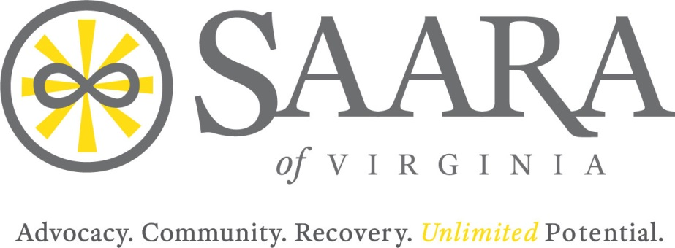
Minutes: Board of Directors Meeting
2000 Mecklenburg Street, Richmond, VA 23223
Saturday, October 19, 2019

Present: Jim May, Nick Yacoub, Barry Travis, Melba Gibbs, Sherri Cotton, Maureen Murphy-Ryan, Johnnie Mullins, Jason Pritchard, Crystal Blanchard

Staff Present: Kathy Harkey, Kelsi Sober
Excused Absence: Laura Minnick, Lisa Beitz
Guests: Jeff Tuck
Call to Order
Called to order by Jim May at 10:18 AM.

Introductions
Financials
The board reviewed the balance sheet and the total assets are just under $160k putting the financials in good standing. None of the affiliates are a separate 501c3. Affiliate accounts receive funds by raising money, membership dues, and received donations. Local affiliates are encouraged to generate revenues by hosting events. RBHA and the DBHDS Advocacy Contract are the main funds for SAARA of Virginia. The DBHDS renewal contract is due at the end of this year. SAARA wants Virginia to consider us a sole source provider so we do not have to bid for contact renewal. Alive RVA needs to seek private funders to help with housing needs. Payroll is currently the biggest expense. Jim May suggest coming up with a map to identify revenue better. Operating reserves need to include 3 months of expenses to start, then transition to 4 months. An operating funds account can be set it up through the bank. A money market account was mentioned. Kathy thinks $87k needs to be in the checking account every month. Our goal financially is to have $90k monthly to assure expenses are covered with a positive balance remaining. Moving forward, funds remaining above $90 will be moved over to SAARA reserves. Kathy has followed up with the status on the federal SAMHSA grant and has not received a response. Funds from the SAMHSA grant were used according to the grant terms and all closeout documentation was sent to SAMHSA. Kathy will continue to send inquiries every quarter despite no response on their end.

*Action Item: Kathy Harkey, Jim May, and Jeff Tuck will create a bullet list of acceptable things to purchase with SAARA credit cards.
Previous Meeting Minutes
Jim May motioned to accept previous meeting minutes. Nick Yacoub seconded. All in favor, Approved.
Executive Report
The Virginia Community Services Board is partnering with SAARA of Virginia in the statewide Substance Use Disorder Advocacy Symposiums. We plan to hold five symposiums in 2020. The SAARA Advocacy Training is complete and will be launching in December or January in the Peninsula area. State contracting can go out for a full RFP where anyone can bid, or do a sole provider where they automatically give funds to SAARA because they believe the organization is the sole source contractor. Jim May request we create a one page on why we should be considered a sole source. For example, stress that we have affiliates all over the state of Virginia that have developed tools to bring advocacy to the street.

Jim will remain acting president and will vote on a president at next meeting.
Vendor Contractors
Contract with Eddy Alexander will not be renewed. We would like to use a local business offering printing services.

SAARA of Virginia needs nice shirts for all staff and affiliates to wear to outreach events. Nick Yacoub has a person that does embroidery and sent his contact info to Jim May.

Jim May motioned to continue working with Commonwealth Bookkeeping on a month to month basis until contract can be reviewed. Barry Travis seconded. All in favor, Approved.

Jim May motioned to authorize Kathy Harkey to use Minute Man Press and bring samples to next meeting. Nick Yacoub seconded. All in favor, Approved.

Voting New Members
Nick Yacoub motioned to vote Maureen, Crystal, Jason and Sherri as board members, Barry Travis seconded. All in favor, Approved.

*Action Item: Kathy Harkey will create a contact list identifying board members.

Whistle Blower: Jeff Tuck suggested adding something about sexual harassment. Jim May suggested creating a different policy for that. Jim May thinks that since we have several new board members they are encouraged to send Kathy any additions to whistle blower policy. It is mandatory to go over whistle blower policy with staff. The whistle blower policy goes into policy and procedures, not the bylaws.

Nick Yacoub motioned to adopt the whistle blower as is and we can make additions or changes later if necessary. Melba Gibbs seconded. All in favor, Approved.

*Action Item: Jim May is going find the form that board previously used to review financials at all board meetings.
Grievance Policy
The grievance policy provides procedural steps if somebody has a complaint. Jim May likes the process the way we have it laid out. Jim May would like to define our terms. For example, there should be a statement that says SAARA of Virginia may be referenced as SAARA or the company, or the organization. This is for employees that want to complain. This applies to paid employees of SAARA of Virginia. As an organization, we need to get into a habit of putting the date, title and page numbers.

*Action Item: Melba Gibbs will send Kathy Harkey the volunteer hold harmless form.
Nick Yacoub motions to carry forth the grievance policy. Barry Travis seconded. All in favor, Approved.
Jim May motions to authorize Kathy to buy a year subscription of Zoom Pro. Nick Yacoub seconded. All in Favor, Approved.

Barry Travis motions to move any money over 90k to operating reserves. Melba Gibbs seconded. All in Favor, Approved.

*Action Item: Kathy Harkey will send out additional information on KHS & Company CPA firm; the firm SAARA will use for July 1, 2018 to June 30, 2019 taxes. Kathy will send the board information on what KHS will include in an audit for SAARA.

New Business
Barry Travis motioned to accept SAARA Southside Hampton Roads as a new affiliate. Nick Yacoub seconded. All in Favor, Approved.

Mission Statement
Our mission currently only focuses on advocacy. Kathy proposes we change the wording of SAARA’s mission to include programs and support because many funders would like to fund programs related to support and not just advocacy. The board agreed to discuss creating a new mission statement at a retreat and everyone should begin coming up with some ideas. The board will take action after the DBHDS report.

*Action Item: Research trainings that can further board develop.
**Action Item: Five Board Manuals need to be created.

The board discussed 3rd parties using the conference room. A decision was made not to allow any 3rd party to use space at SAARA until research has been done on protocols (ex: rental fees, insurance needed, terms, etc.)

Affiliate Updates
SAARA Central Virginia hosted a successful recovery event. Nearly 200 people attended the fall into wellness field day. The event had bands, food, contest, prizes, and crafts. The affiliate also participated in the 2019 Art of Recovery.

SAARA of Northern Virginia continues social media engagement and promoting events in the recovery community. Nick Yacoub knows of someone who is interested in hosting a Recovery Unhooked event.

SAARA of Southwest is considering changing affiliate name to SAARA of Greater Roanoke Valley. The affiliate has been doing lots of outreach at hospitals.

SAARA of Bay Counties hosted a successful Recovery Walk. The affiliate continues to advocate for substance use disorder and addiction awareness in the region.

SAARA Roanoke is involved in the upcoming Recovery is Real conference to create awareness, educate the community, and reduce stigma.

SAARA of the Peninsula held a Recovery Gala during Recovery Month. They continue to provide recovery support in the local jail. The affiliate is active in the community and partners with other local agencies.

Jim May has Laura Minnicks Proxy
Jim May motioned to adjourn meeting. Barry Travis seconded. All in favor, Approved.
Meeting Adjourned 2:04 PM
Next Meeting January 11th or 18th. Send email and agree on a date.
Meeting Minutes Recorded by Kelsi Sober

